**How To Solve Sudoku in Python?**

I have always been an avid Sudoku solver since quite some years now so much so that I had solved this book in 10 days flat ☺

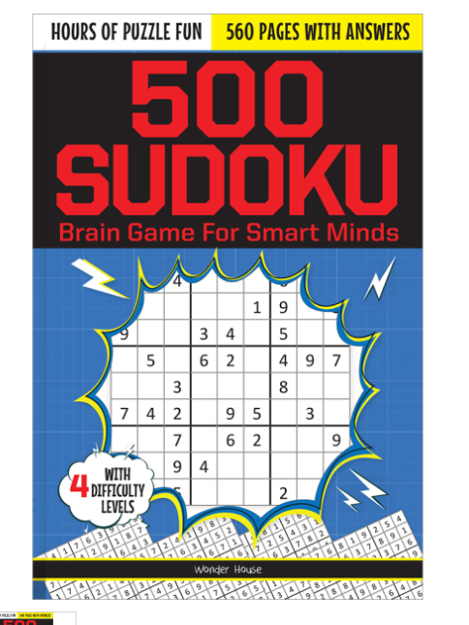

It gave me so much joy to solve a puzzle, so now let me bring one of the puzzles to you:-

**Medium Puzzle 191**

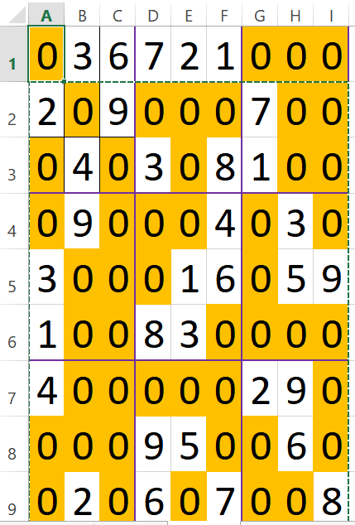

All numbers which are originally empty are marked orange /0

Lets try to solve cell B2

**Check 1-> Every number in a row should be unique**

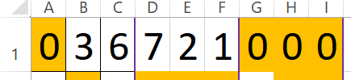

So B2 cannot be 2,9, 7: possible solutions-> [~~1~~,~~2~~,~~3~~,4,5,~~6~~,~~7~~,8,9]

This check is from (A,1) to (I,1)

So updated possibilities include the unstruck numbers

Or another approach->

if I run a for loop for numbers between 1 to 9, it returns false as possible solutions for 1,2,3,6,7 (These numbers are excluded as possibilities)

Lets go by this alternative approach in below checks

**Check 2 -> Every column in a column should be unique**

This check is from (B,1) to (B,9)

The list of possibilities return false for 3, 4, 9,2



Now the check 3

**Check 3-> Every cell in a given square should be unique**

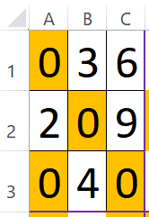

Check is from x1,y1 to x3,y3 in Square 1

The false is returned for 3,6,2,9,4

Check 1 False->1,2,3,6,7

Check 2 False->3,4,9,2

Check 3 False->3,6,2,9,4

So possibilities could be->5,8

Now the task is what is x1 and y1, x3 and y3 (Remember we have known values for row, column and the number we are checking) (Also A=row 1, D=row 4, G=row 7 etc.)

|  |  |  |
| --- | --- | --- |
| Square No | X 1(row) | Y 1(column) |
| 1 = (A,1) | 1 | 1 |
| 2=(D,1) | 1 | 4 |
| 3= (G,1) | 1 | 7 |
| 4=(A,4) | 4 | 1 |
| 5=(D,4) | 4 | 4 |
| 6=(G,4) | 4 | 7 |
| 7=(A,7) | 7 | 1 |

So X1 = 1 (for square numbers 1 to 3)

X1= 4 (for square numbers 4 to 6)

X1= 7 ( for squares 7 to 9)

So xi=i+ 3* (square number-1) or square no= (xi-i)/3 +1

Yi= (Square number-1)*3 + i

Then traverse from x1 to x3 by adding +1 to +2 row and similarly for y1, y2, y3 etc.

Or calculate xi equation using row and columns only ie, given column find the row for xi and vice versa for yi

Xi=(column//3)*3

Yi=(row//3)*3

**Now after getting false for non-possibilities, let’s try to solve**

Number is given to possible function

If it returns false for that no for all checks; go to next number (number+1 in 1 to 9)

If every thing is exhausted till 9 mark that grid 0 (not solved)

Go to previous step and put next possibility in previous step and so on ( ie if number is repeating in current step, back track error in previous steps)